**7.1.3 - Describe the facilities in the institution for the management of the following types of degradable and non-degradable waste**

**Oxidation tank**

To minimize wastage of municipal supply water and promote efficient use, an underground water tank has been built in the garden to collect water, which is then pumped to overhead tanks for a continuous water supply.

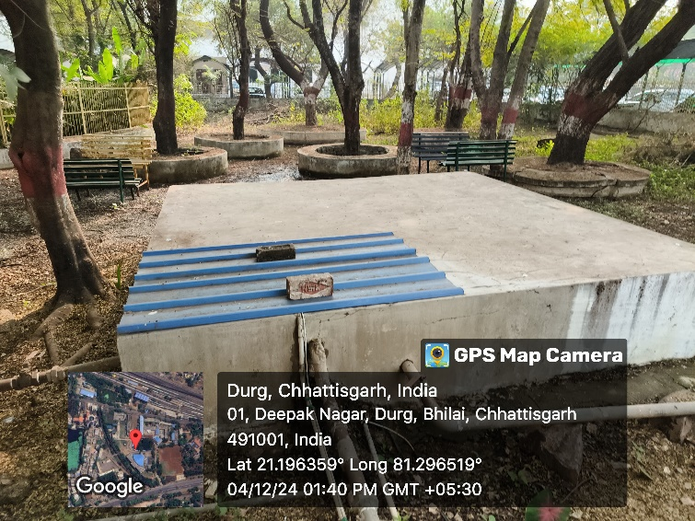

**Waste water recycling**

It primarily aids in alleviating water scarcity on the campus. It can be utilized for developing or improving wetlands.  
  
Wastewater released from the canteen is funnelled into a small container called the Lotus tank. It is enclosed by a wire netting. The aquarium holds a range of visually striking water plants. The water from this pond is utilized to irrigate the adjoining seasonal plant beds.

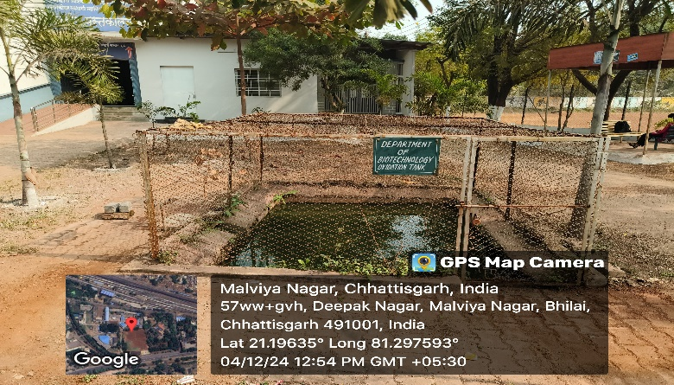

Potted plants are positioned beneath the Air Conditioner outlets to efficiently use the water that is discharged from these outlets.

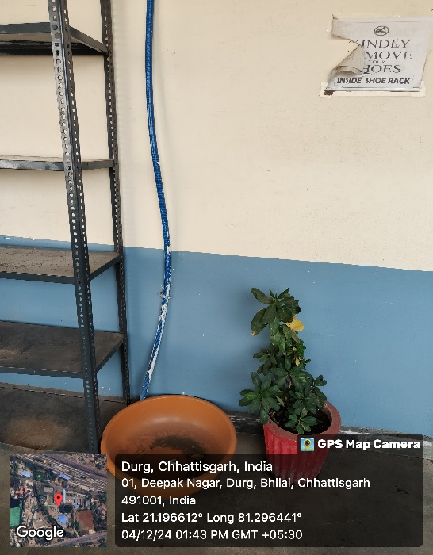 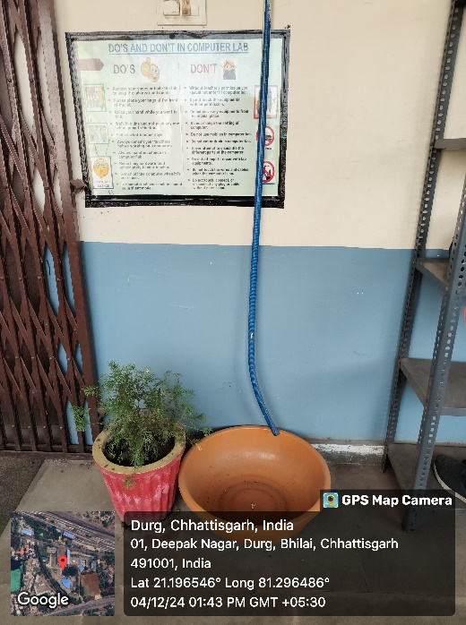

A temporary pond has been built next to the girls' hostel to gather water from the Railway washing yard situated close to the college campus. The pond acts as a recharge source for underground water, and a portion of it is utilized for on-site construction and the irrigation of plants distributed throughout the college campus.

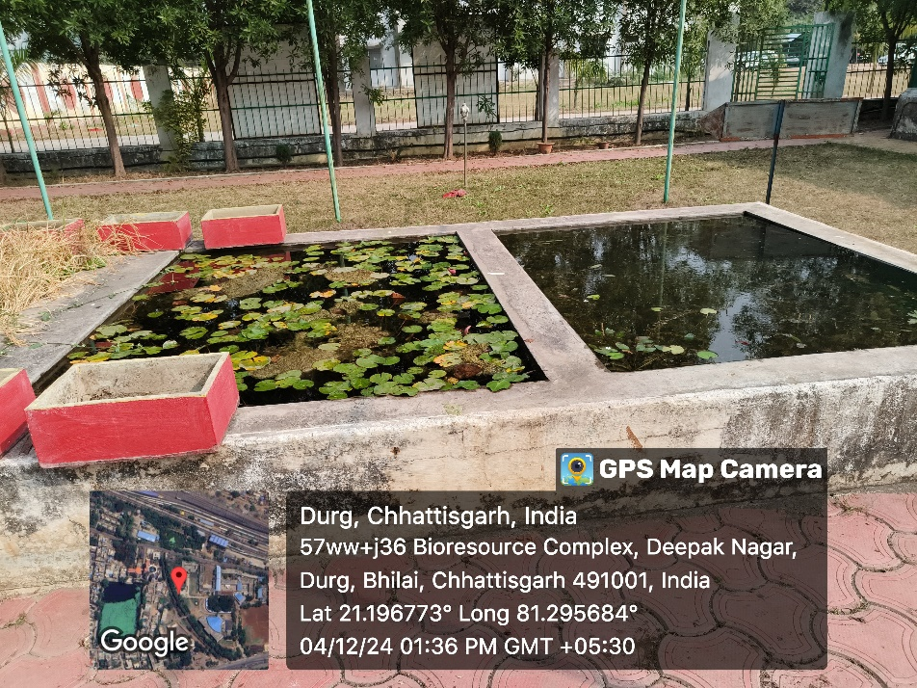

**Solid Waste Management**

●**Distinct bins for various waste types are positioned around the campus at key locations for effective collection and sorting of waste. This avoids any mixing of wastes and is advantageous for the use and recovery of components via sustainable waste management.**

**●Paper waste produced on campus is gathered and recycled on-site.**

**●In accordance with the green protocol, the college enhances paper usage efficiency by utilizing technology for sharing information and documentation. Office automation has greatly helped in minimizing paper waste.**

**●The consumption of single-use plastic is completely prohibited on the campus. Students collect plastic bottles, which are recycled and used as planters in our garden**.

* **The Bio-resource Complex at College campus houses Composting Pits and Vermicomposting for managing biodegradable wastes**

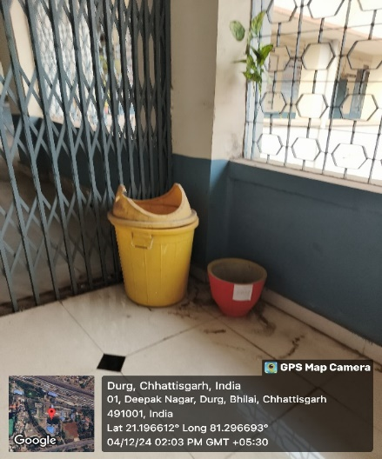 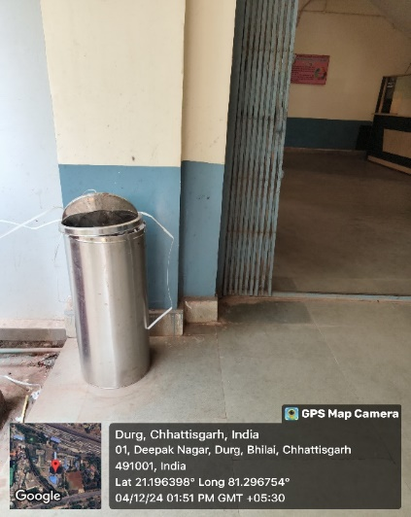

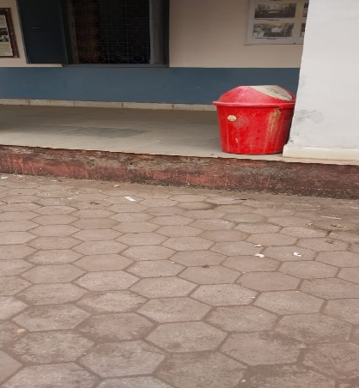 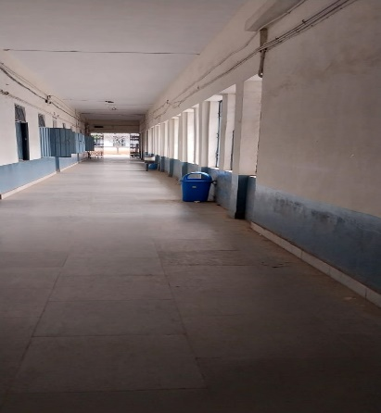

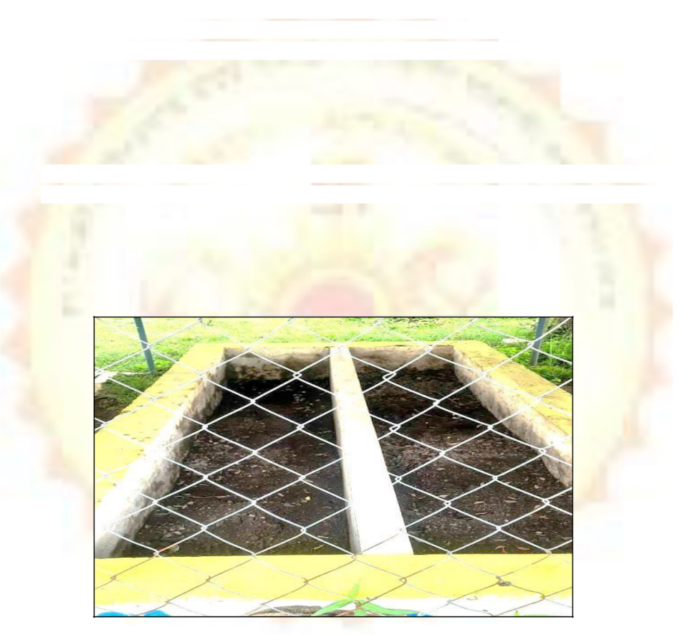

**Vermicomposting Pit**

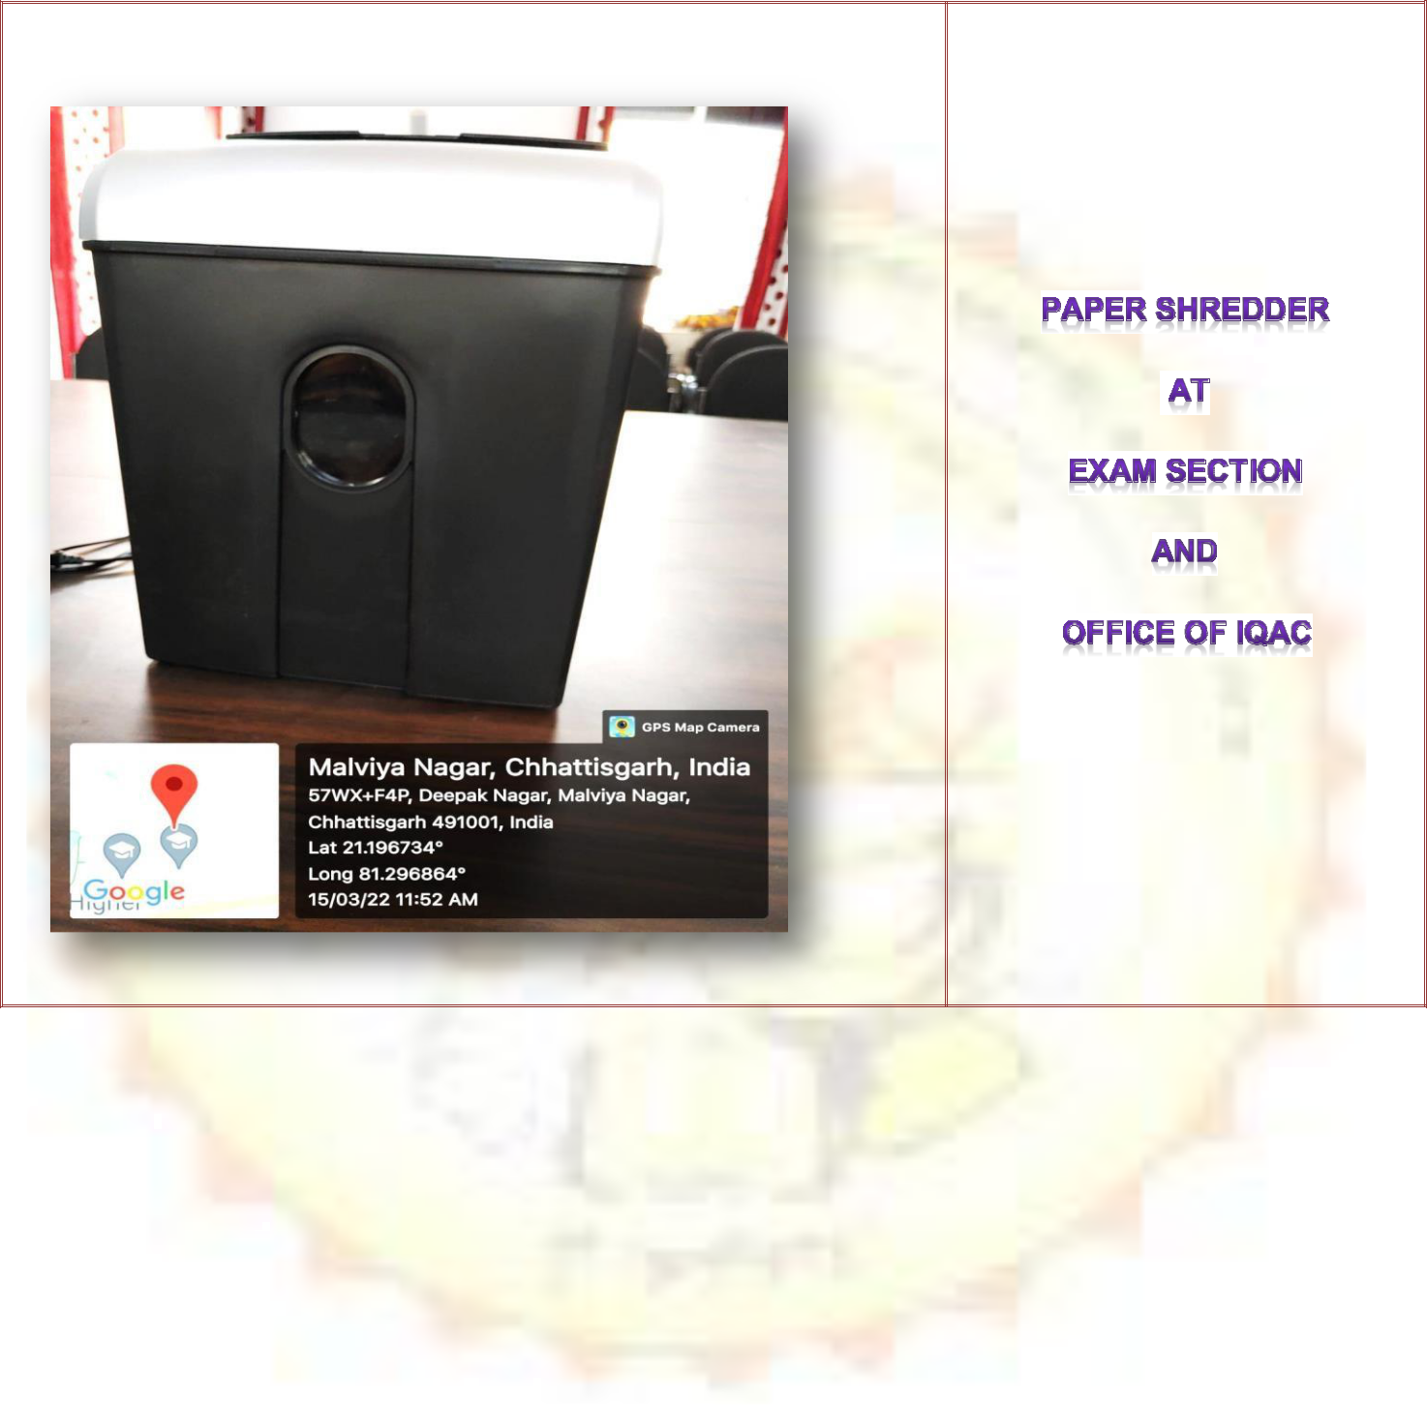

**Liquid Waste Management**

* Solvents are reclaimed and utilized again in the laboratory. Solvent blends are eliminated via soak pit.
* Aligned with its 3R policy, rainwater collected from the harvesting system is utilized in gardens and restrooms.

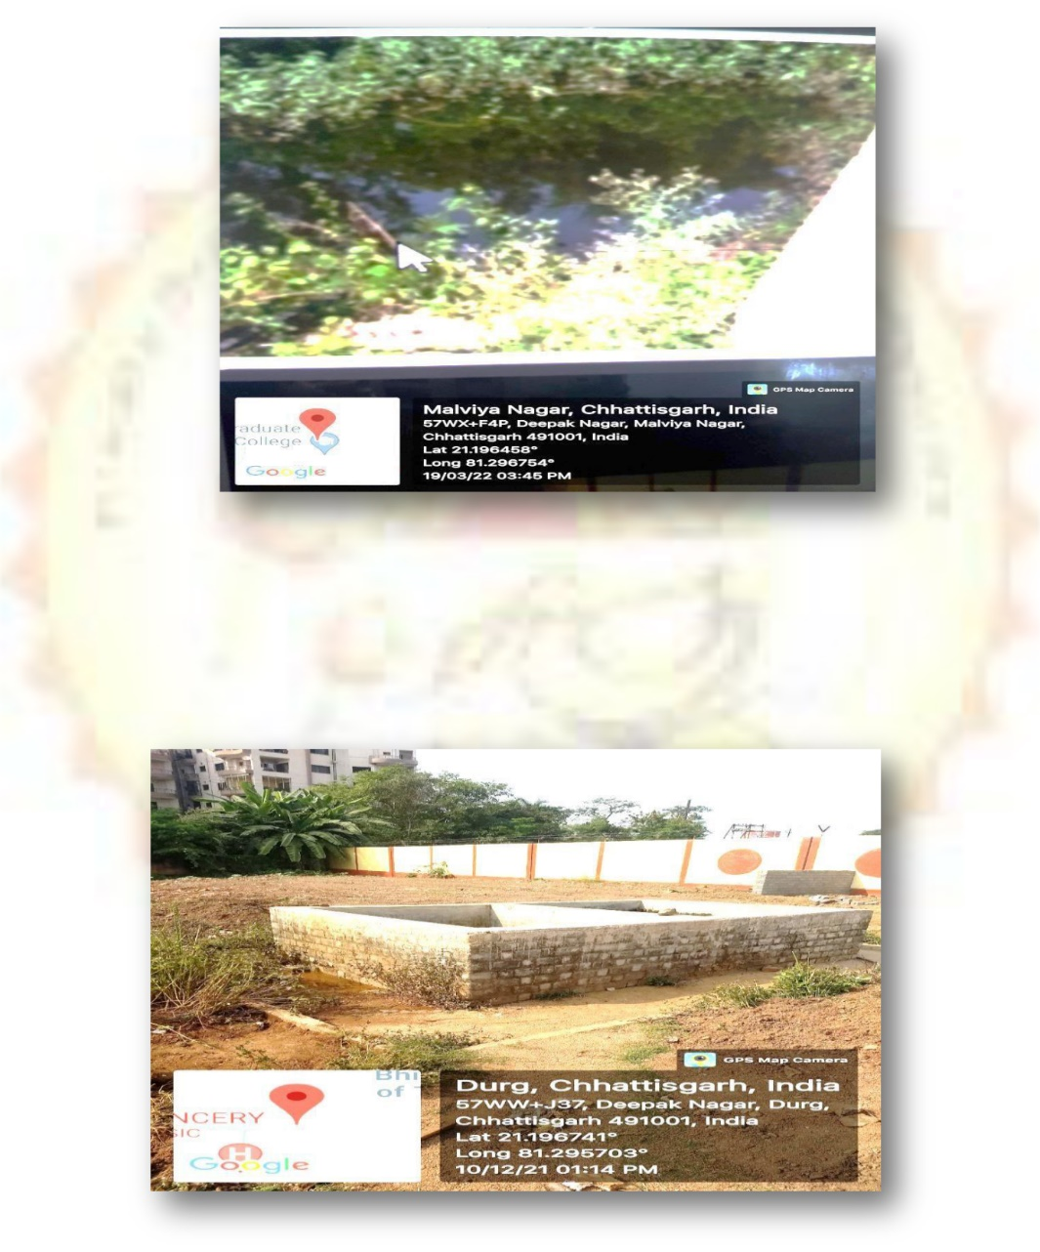

**Maintenance of water bodies and distribution system in the campus**

The water bodies are consistently managed to deliver sustainable, reliable, economically safe, and sufficient water to the campus with the assistance of the municipal corporation and bore wells. The primary aim of the maintenance is to ensure a disease-free environment. Water is distributed via a well-equipped network of pipes, filters, and coolers. In certain areas, drinking water is purified through the process of ozonisation. Inspections of the machinery are scheduled on a daily, weekly, monthly, and yearly basis on the campus. The overall system on the campus is properly maintained and monitored by the college's maintenance department. Over 10 water purifiers are set up at different locations across the college campus. The wastewater from these purification outlets is utilized to irrigate numerous indoor and outdoor plants, promoting minimal water waste and enhancing campus aesthetics.

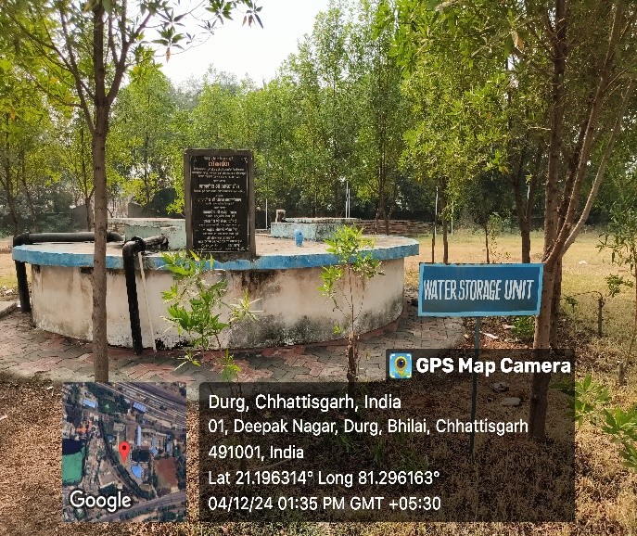 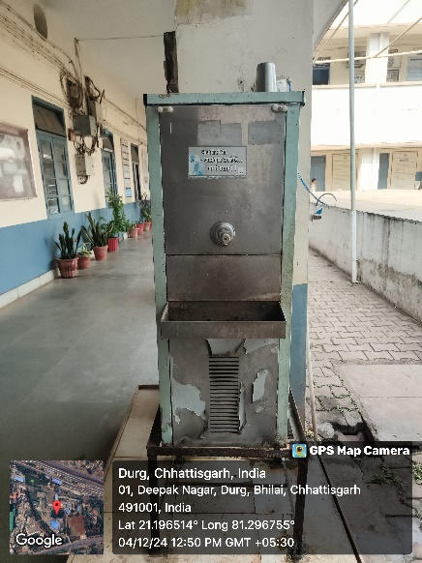

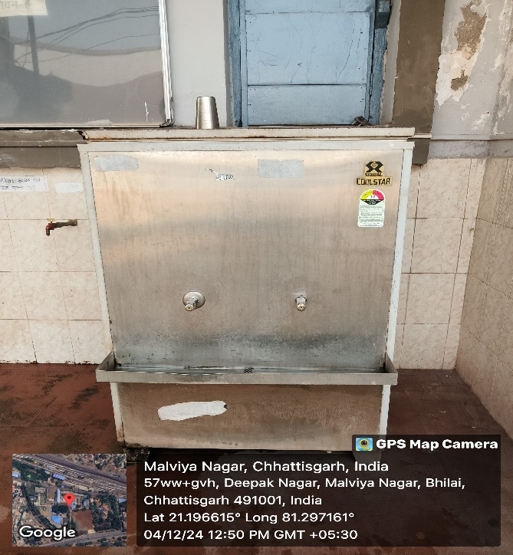 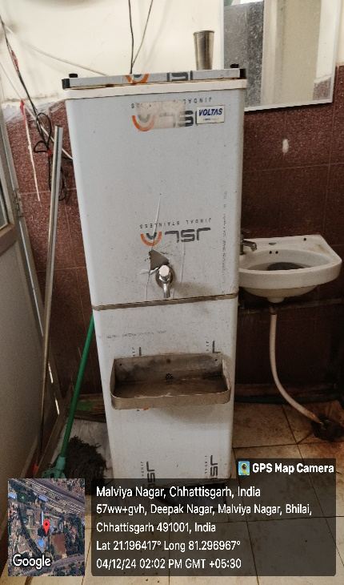

**E-waste Management**

* A minimal e-waste generation is ensured by optimal and periodic maintenance of computers and other electronic peripherals.

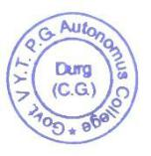

**Principal**

**Govt.V.Y.T.PG Autonomous**

**College, Durg**